**Week 1 Quiz**

1. Consider the table below describing a data set of individuals who have registered to volunteer at a public school. Which of the following is a discrete numerical variable?

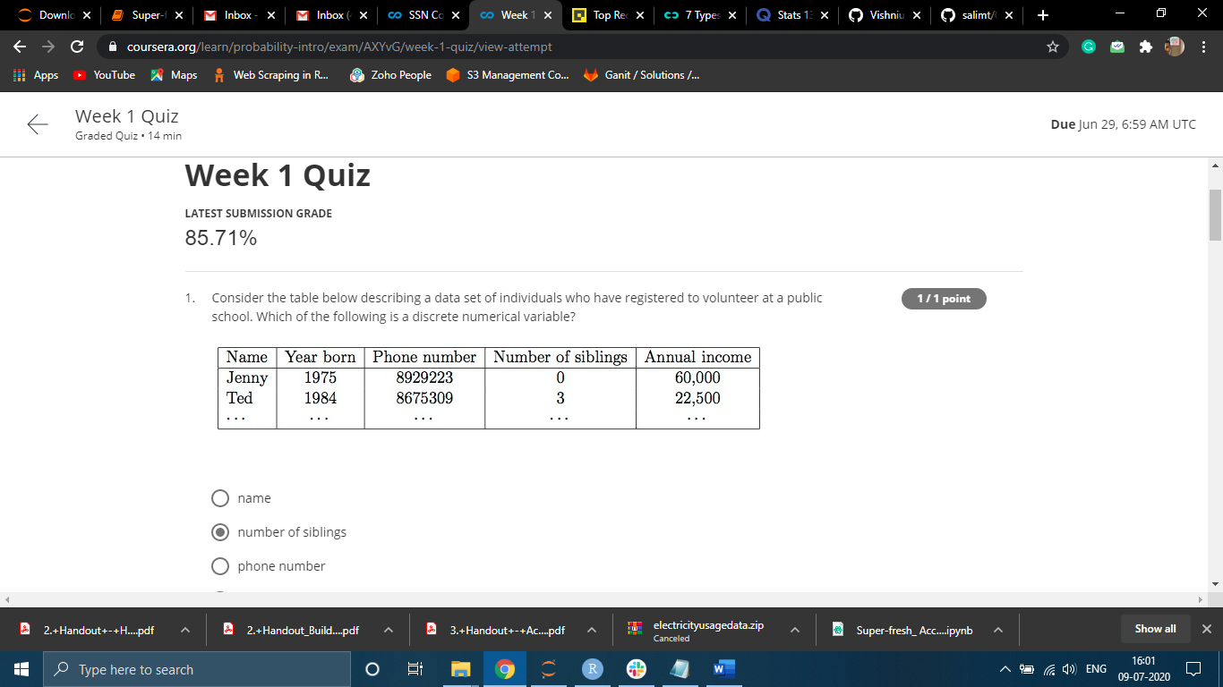Number of Siblings

2. A study is designed to test the effect of type of light on exam performance of students. 180 students are randomly assigned to three classrooms: one that is dimly lit, another with yellow lighting, and a third with white fluorescent lighting, and given the same exam. Which of the following correctly identifies the variables used in the study as explanatory and response?

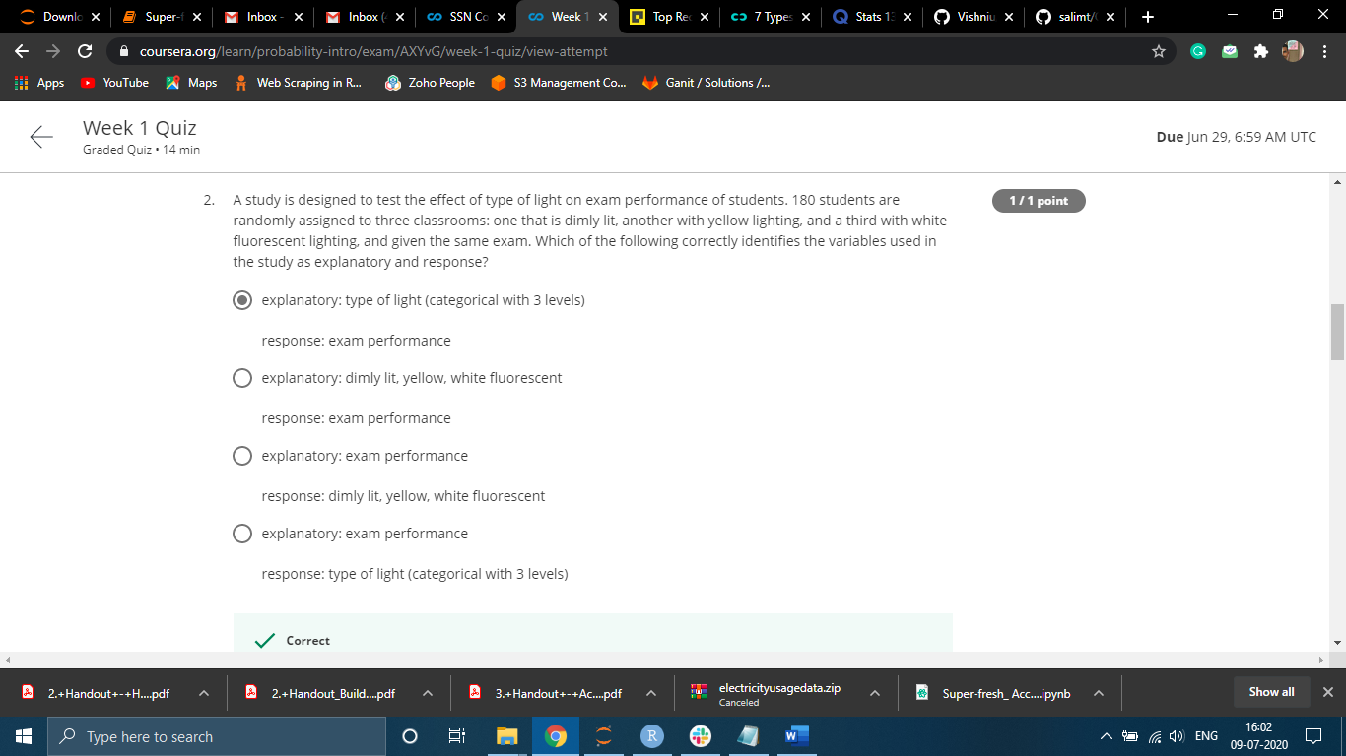

3. Past research suggests that students who study with fewer distractions (internet, cell phone, etc.) tend to get higher grades. Which of the following is the best scenario for being able to generalize this finding to the population of all students?

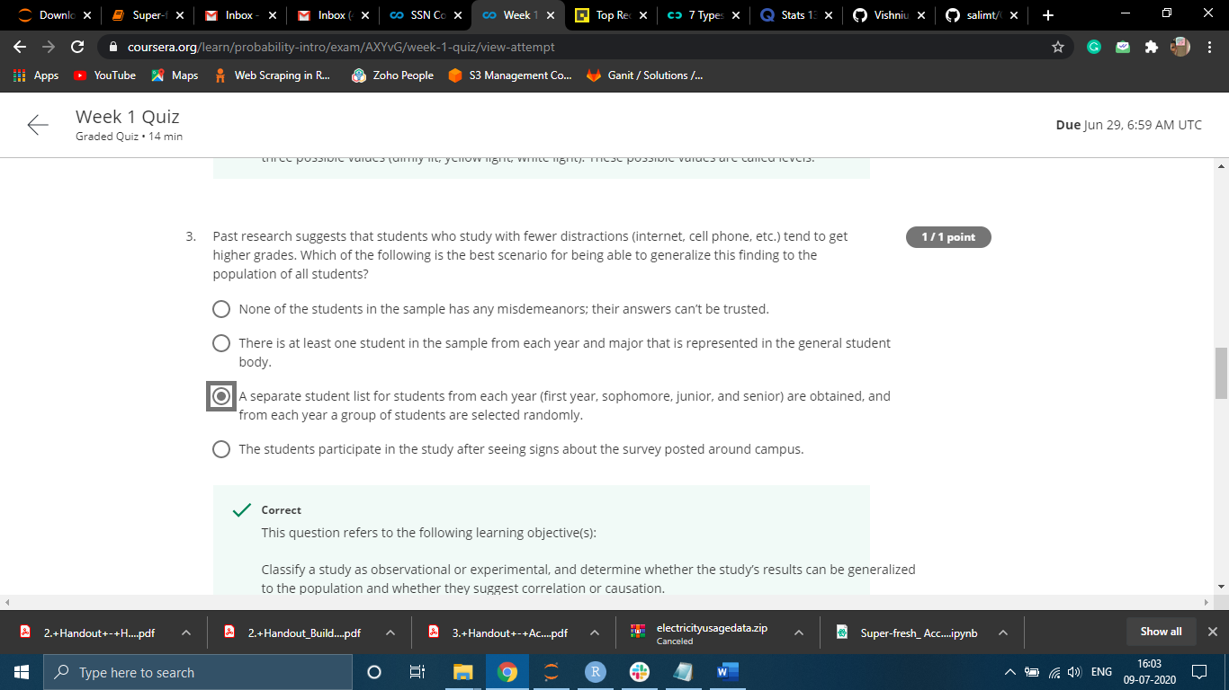

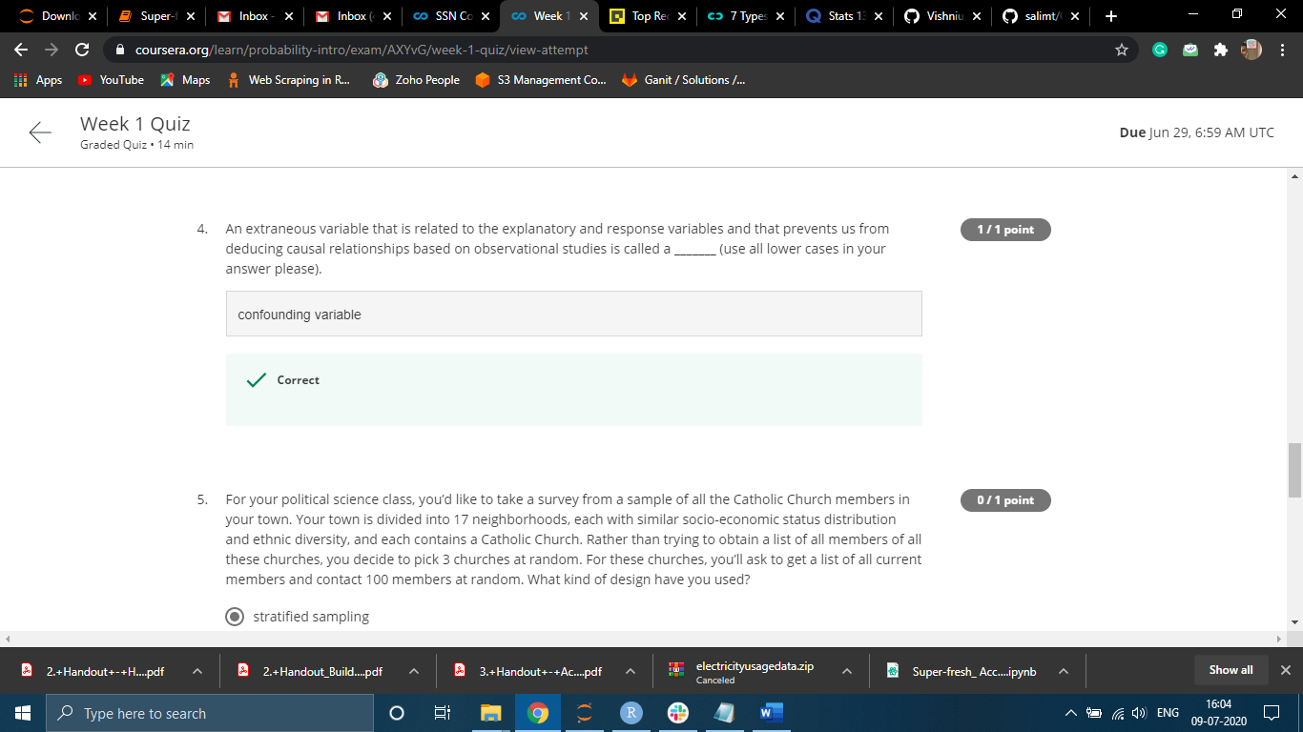

5. For your political science class, you’d like to take a survey from a sample of all the Catholic Church members in your town. Your town is divided into 17 neighborhoods, each with similar socio-economic status distribution and ethnic diversity, and each contains a Catholic Church. Rather than trying to obtain a list of all members of all these churches, you decide to pick 3 churches at random. For these churches, you’ll ask to get a list of all current members and contact 100 members at random. What kind of design have you used?

Simple random Sampling

6. Which of the following is not one of the four principles of experimental design?

cluster

7. Which of the following is one of the four principles of experimental design?

Randomize